June 2023

The Great British Summer has arrived!
Sunburn increases your risk of skin cancer. Sunburn does not just happen on holiday. You can burn in the UK, even when it's cloudy.

Sun safety tips
Spend time in the shade when the sun is strongest. In the UK, this is between 11am and 3pm from March to October.
Make sure you:
spend time in the shade between 11am and 3pm
never burn
cover up with suitable clothing and sunglasses
take extra care with children use at least factor 30 sunscreen
https://www.nhs.uk/live-well/seasonal- health/sunscreen-and-sun-safety/

Stay Safe - Be Water Aware
#FloatToLive
Laisteridge Lane,

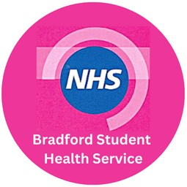Bradford, BD5 0HR
01274 371380

Hay fever

Hay fever is usually worse between late March and September, especially when it's warm, humid and windy. This is when the pollen count is at its highest.
Symptoms of hay fever include: sneezing and coughing
a runny or blocked nose itchy, red or watery eyes
itchy throat, mouth, nose and ears loss of smell
pain around your temples and forehead headache
earache feeling tired
If you have asthma, you might also: have a tight feeling in your chest
be short of breath wheeze and cough

Consult a Pharmacy if you have hay fever.
They can give advice and suggest the best treatments, like antihistamine drops, tablets or nasal sprays to help

Please talk to your young people about the dangers of cooling off in rivers, lakes & reservoirs.
If you see someone in trouble remember #CallTellThrow.
Call 999 - ask for Fire. Tell them to float on their back throw them something that floats.

Mental Health Struggles?
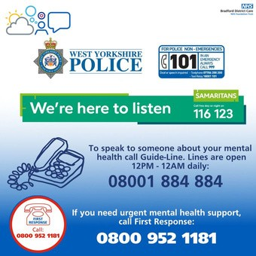
Remember, you are not alone.
If you feel in mental health crisis, you can call the following:

First response 0800 952 1181 (24/7), Samaritans 116 123(24/7), Mind in Bradford Guideline
0800 1884884 (12pm-12am) or call 999.
#support #depression

Returning home for Summer? Patient Engagement
As exam season is upon us and as you prepare

to return home for the summer, its important you are aware of how best to access the NHS until your return.

Did you know we offer Electronic Prescriptions?
If you take regular medication, you can nominate a pharmacy to receive your repeat prescriptions electronically. Please ask reception for more information.
If you fall ill whilst at home you can also temporarily register at your local GP. Upon your return you can continue your NHS care with us here at Bradford Student Health Service. NHS 111, 999 & A&E are also available to access in your local area.

Do you have access to your NHS Online Services?
Pay us a visit in the practice with some photo ID and we can provide you with the details needed to send your online access request to your GP. Having online access allows you to view your medical record should you need to, request repeat medication and view
appointments.
Your feedback and views are extremely important to us.

We use them to shape the services that we provide and commission. We will keep you informed about what is happening within the practice and of the important changes happening within the NHS.

You can join our Patient Engagement group by contacting Elaine on 01274 371380, follow us on Twitter @BSHSDOCS, or find us on Facebook - Bradford Student Health Service.
You can also call in to the practice and post a suggestion in the suggestions box in the waiting area or fill out our Patient Survey which is available from reception.

Positive patient experience is our main aim and we would like to hear your views, we welcome the positives and any suggestions on improvements so we can work on providing the best possible care and patient experience.

Useful Contacts
Bradford Student Health Service - 01274 371380
First Response - 0800 952 1181
MyWellBeing College - 0300 555 5551
Locala Sexual Health - 0303 3309500
or text a Nurse on 07312 263 032
Bradford Royal Infirmary - 01274 542200
TB Clinic - 01274 323439
Early Pregnancy Unit (BRI) - 01274 364325 Bradford Travel Clinic - 01274 750660 Bradford Uni Eye Clinic - 01274 234649
BRI Hospital Appointment Line - 01274 274274

#NationalBloodWeek
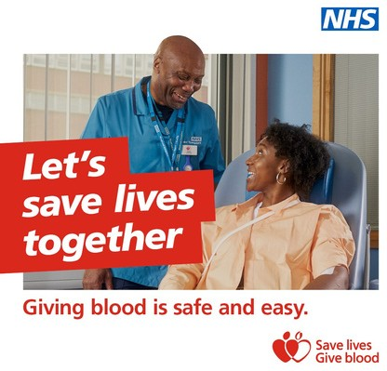
NHS England - In one hour you could help save up to three lives. This #NationalBloodWeek, join the thousands of people giving blood every day.
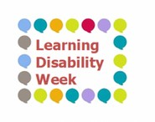
Book now at http://blood.co.uk.

June Awareness
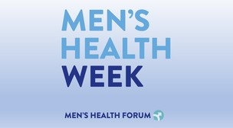
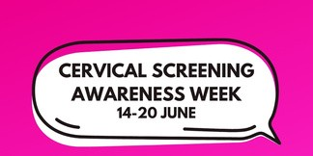
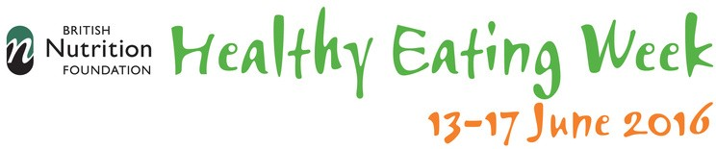

Bradford University Postgraduate Open Day - Saturday 8 July.

Find out about courses, career options, funding, and life as a postgraduate student at Bradford.

Book your place now:
https://bit.ly/3J2uWMk

5- 12 June is #CarersWeek.
The theme for this year is 'Recognising and supporting carers in the community'
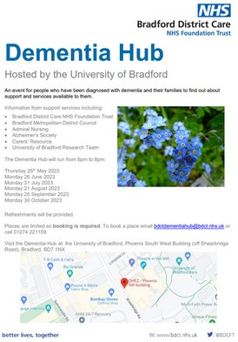
Join us at @UniofBradford
for one of @BDCFT's brand new monthly Dementia Hub sessions. A hub of support, provided by #carers in our community.

