Bradford Student Health Service
Coughs & Colds

CATCH IT

Germs spread easily. Always carry tissues and use them to catch your cough or sneeze.

BIN IT

Germs can live for several hours on tissue bin it as soon as possible.

KILL IT

Hands can transfer germs to every surface you touch. Clean your hands as soon as you can.
Flu vaccinations

Don't wait until there is a flu outbreak this winter:
Contact us on 01274 371380 now to find out if you are eligible for a free flu jab and make an appointment.
Meningitis ACWY

All Freshers aged between 16-25 years are advised to have a Meningitis ACWY vaccination to boost their immunity as soon as possible after starting University.

Welcome to Bradford Student Health Service
We specialise in student health, offering a confidential service but we can liaise with University departments should there be any health issues affecting your studies (only with your consent) and will look after all your health needs while you study in Bradford.
Christmas

Christmas is around the corner and who doesn’t love a Christmas party and a mince pie, or two, or three? However, this is a time when many people find themselves drinking more than they usually do.
If you choose to drink alcohol this Christmas:
- Keep in mind the NHS low risk drinking guidelines and try not to drink more than 14 units, which is six standard glasses of 13% wine or six pints of 4% beer, in any week.
- If you choose to drink this much, then spread the drinking over three or more days and avoid binge drinking. Visit drinkaware.co.uk/app to help track and calculate your units
- And looking ahead to 2021: The New Year is a fantastic opportunity for people to really look at the amount of alcohol they drink and, where necessary, to make long lasting changes to their drinking that can benefit their health and wellbeing

Tis the season to be…..?
Although the Christmas carol says “merry”, Christmas can be a season of poor mental health for some people. It can be a stressful time of year with everything that needs to be done and if you are feeling anxious, sometimes Christmas can add to the pressure you feel. Add to that the pressure that you’re not socialising with people you normally spend time with, and it can all add up. Make sure you are not using alcohol to manage any anxiety or depression. Find healthier ways to manage your mood such as exercise, time with good friends and family and adequate sleep.

How to stay well this winter
During the winter season many people catch a cold or flu. Nobody wants to become sick – it can slow you down, make you miserable and stop you from doing things. To avoid becoming ill keep yourself healthy and make sure that you avoid catching and spreading germs and diseases, wash your hands, keep warm, drink plenty of water.

Coronavirus update
The COVID vaccine roll-out has started and nurses, paramedics, pharmacists and other NHS staff will work alongside GPs to vaccinate those aged 80 and over, as well as care home workers and residents, identified as priority groups for the life-saving vaccine.
Along with other countries in the UK, residents of care homes in England will also receive their first vaccine later this week after distributors finalise new, stringent processes to ensure safe delivery of the PfizerBioNTech vaccine.
In areas one, two and three Christmas bubbles will not be allowed to meet across the five day period. Instead, three households coming together will now only be allowed on Christmas day. People in these tiers are also being asked to stay local. Bubbles can meet each other in each other’s home, a place of worship, and in outdoor public spaces or garden. People who are self-isolating should not join a Christmas bubble. If someone tests positive, or develops coronavirus symptoms up to 48 hours after the bubble last met, everyone has to self-isolate. If this happens, there is always the option of Zoom video calls to contact friends and family – its free and simple and a good way to keep in touch. Either Google Zoom or download the app.

Flu Vaccine
The NHS has unveiled the largest flu campaign ever. Flu can have serious consequences and vulnerable people can die of it. Having the vaccine protects you and helps reduce transmission to others. This winter more than ever, with COVID-19 still circulating, we need to help reduce all avoidable risks. Vaccinating more people will help reduce flu transmission and stop people becoming ill.
A free flu vaccine is available to:
- People aged 65 and over
- Pregnant women
- People with some pre-existing conditions
- All school year groups up to Year 7
- Household contacts of those on the NHS shielded patient list

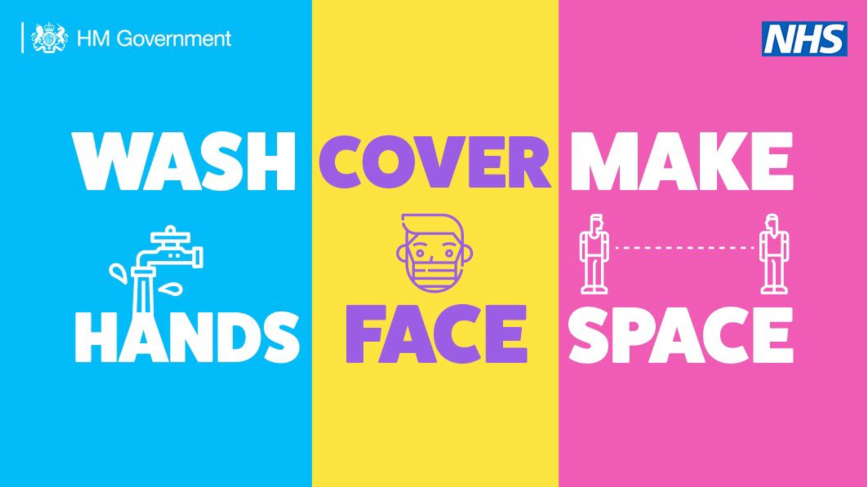

Local COVID Alert Level – Medium
This is for areas where national restrictions continue to be in place. This means:
- All businesses and venues can continue to operate, in a COVID-19 Secure manner, other than those that remain closed in law, such as nightclubs.
- Certain businesses selling food or drink on their premises are required to close between 10pm and 5am.
- Businesses and venues selling food for consumption off the premises can continue to do so after 10pm as long as this is through delivery service, click-and-collect or drive-thru.
- Schools, universities and places of worship remain open
- Weddings and funerals can go ahead with restrictions on the number of attendees
- Organised indoor sport and exercise classes can continue to take place, provided the Rule of Six is followed
- People must not meet in groups larger than 6, indoors or outdoors

Local COVID Alert Level – High
- This is for areas with a higher level of infections. This means the following additional measures are in place:
- People must not meet with anybody outside their household or support bubble in any indoor setting, whether at home or in a public place
- People must not meet in a group of more than 6 outside, including in a garden or other space.
- People should aim to reduce the number of journeys they make where possible. If they need to travel, they should walk or cycle where possible, or to plan ahead and avoid busy times and routes on public transport.

Local COVID Alert Level – Very High
This is for areas with a very high level of infections. The Government will set a baseline of measures for any area in this local alert level. Consultation with local authorities will determine additional measures.
The baseline means the below additional measures are in place:
- Pubs and bars must close, and can only remain open where they operate as if they were a restaurant – which means serving substantial meals, like a main lunchtime or evening meal. They may only serve alcohol as part of such a meal.
- Wedding receptions are not allowed
- People must not meet with anybody outside their household or support bubble in any indoor or outdoor setting, whether at home or in a public space. The Rule of Six applies in open public spaces like parks and beaches.

Healthy Body, Healthy Mind
Things to do to stay well at University

Register with a local GP You never know when you might need one, so register as soon as you arrive on campus and put your safety net in place.
Have any immunisations you are due Get vaccinated for Meningitis ACWY and MMR when you arrive at University if you haven't done it already. Living in large communities puts you at risk of infections you may not have previously considered.
Check out the counselling service and any other support services/peer support on offer. Just in case...
Download useful IT Save your GP practice website to your favourites and apply for an online appointment booking password. Take control of your health and download the Evergreen Life app
www.evergreen-life.co.uk

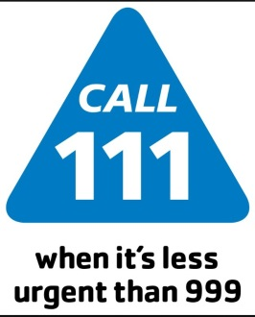

Emergency and urgent care services

You should use the NHS 111 service if you urgently need medical help or advice but it's not a life threatening situation.
Call 111 if:

- You need medical help fast but it's not a 999 emergency
- You think you need to go to A & E or need another NHS urgent care service
- You don't know who to call or you don't have a GP to call
- You need health information or reassurance about what to do next
For less urgent health needs, contact your GP of local pharmacist in the usual way.
Useful contacts
Counselling service 01274 235750

Students union 01274 233300

Information Shop for Young People 01274 432431
Sexual Health Clinic 01274 200024
NHS www.nhs.uk

Patient Engagement

Your feedback and views are important to us. We use them to shape the services that we provide and commission. We will keep you informed about what is happening within the practice and important changes happening within the NHS. You can join our Patient Engagement group by contacting Elaine on 01274 371380, follow us on Twitter @BSHSDOCS, or call in to the practice and post a suggestion in the suggestions box in the waiting area.
Positive patient experience is our main aim and we would like to hear all your views from things you think we do well to things you think we can do better.

Extended Access Service
This Practice is part of the extended access service, which provides out of hours GP, Physiotherapy, Nurse, Counselling and Mental Health appointments from various hubs across Bradford (please contact the surgery for more details)
Courtesy and Respect
Our staff come to work to care for others, and it is important for all members of the public and our staff to be treated with courtesy and respect. In line with the rest of the NHS and to ensure this is fully observed, we have a Dignity at Work and Zero Tolerance policy. This means that aggressive or violent behavior will not be tolerated under any circumstance.

IMPORTANT HEALTH MESSAGES
Mental Health

Its normal to feel down, anxious or stressed from time to time, but if these feelings affect your daily activities, including studies, or don’t go away after a couple of weeks, get help!

Signs of depression and anxiety include: feeling low, feeling more anxious/agitated than usual, losing interest in life, losing motivation, become withdrawn, having sleep problems or put on or lose weight.

Talk to someone - Telling someone how you feel, whether it’s a friend, counsellor or Doctor, may bring an immediate sense of relief.

University counselling services – University of Bradford have a free and confidential in-house counselling service you can access.

Online self-help – there are also online self-help services you may like to explore, such as NHS Choices’ Moodzone and the Students Against Depression website.

