Bradford Student Health Service

Suffering from Hay Fever?
Hay fever is a common allergic condition that affects up to one in five people at some point in their life.
Hay fever can often be controlled using over-the-counter medication from your pharmacist. However, if your symptoms are more troublesome it’s worth speaking to your GP, as you may require prescription medication.

Coronavirus Update

To protect yourself and others DO NOT come to the surgery unless a GP has given you an appointment

If you have a pre booked appointment this will now be triaged over the telephone to confirm you are well enough to attend.

We would also advise and encourage patients to use E-consult on our website

Roadmap out of lockdown
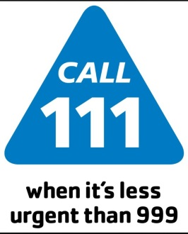

Emergency and urgent care services

You should use the NHS 111 service if you urgently need medical help or advice but it's not a life threatening situation.
Call 111 if:

- You need medical help fast but it's not a 999 emergency
- You think you need to go to A & E or need another NHS urgent care service
- You don't know who to call or you don't have a GP to call
- You need health information or reassurance about what to do next
For less urgent health needs, contact your GP of local pharmacist in the usual way.
Useful contacts
Counselling service 01274 235750

Students union 01274 233300

Information Shop for Young People 01274 432431
Sexual Health Clinic 01274 200024
NHS www.nhs.uk

Coronavirus Vaccine
The coronavirus (COVID-19) vaccine is safe and effective. It gives you the best protection against coronavirus. The COVID-19 vaccine is given as an injection into your upper arm. It’s given in 2 doses and you will have the second dose 3-12 weeks after. For more information click on the link https://www.nhs.uk/conditions/coronavirus-covid-19/coronavirus-vaccination/coronavirus-vaccine

Awareness Days
